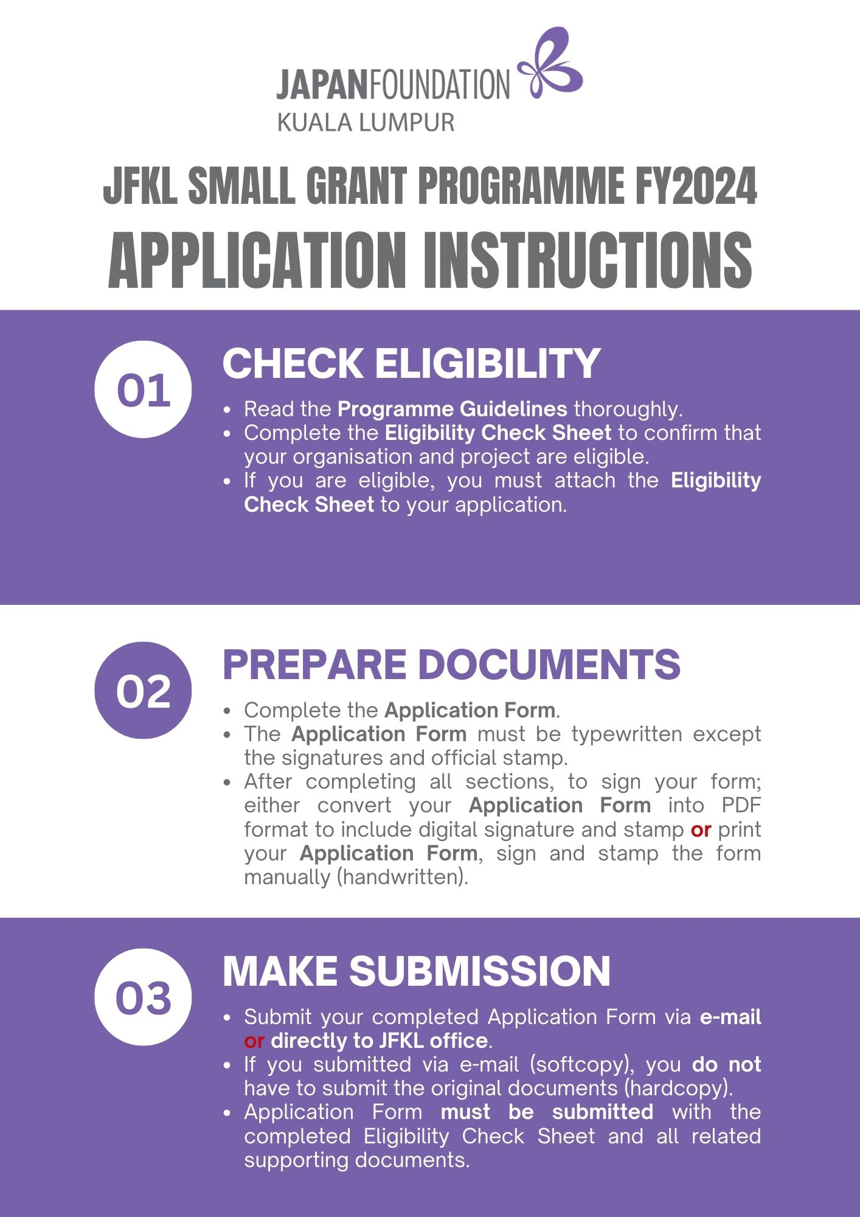



**JFKL Small Grant Programme FY2024**

**Application Form**

|  |  |  |  |  |  |  |  |  |  |  |  |  |  |  |
| --- | --- | --- | --- | --- | --- | --- | --- | --- | --- | --- | --- | --- | --- | --- |
|  | **Date:** | | | | | | | | Click or tap to enter date of application | | | | | |
| **1.** | **Title of the Project:** | | | | | | | | | | | | | |
|  | Enter the title/name of your project | | | | | | | | | | | | | |
|  |  | | | | | | | | | | | | | |
| **2.** | **Category of the Project:**  *Please check/choose ONE (1) box only.* | | | | | | | | | | | | | |
|  | **Category A** | | | | | | | | | | | | | |
|  | Performance | | | | Exhibition | | | | | | Film Screening | | | |
|  | Publication | | | | Other | | | | | |  | | | |
|  | **Category B** | | | | | | | | | | | | | |
|  | Conference/Seminar/Workshop/Masterclass | | | | | | | Publication | | | | | | Other |
|  | **Category C** | | | | | | | | | | | | | |
|  | Conference | | | | Teacher Training | | | | | | Publication of Teaching Resources | | | |
|  | Support for Resource Centre/Library | | | | | | | | | | Other | | | |
|  |  | | | | | | | | | | | | | |
| **3.** | **Types of the Project:** | | | | | | | | | | | | | |
|  | Physical | | | | Online | | | | | Hybrid (Physical & Online) | | | | |
|  |  | | | | | | | | | | | | | |
| **4.** | **Project Period:** | | | | | | | | | | | | | |
|  | From | Click or tap to enter your start date | | | | | To | | | Click or tap to enter your finish date | | | | |
|  |  | | | | | | | | | | | | | |
| **5.** | **Project Venue(s) / Online Platform(s):** | | | | | | | | | | | | | |
|  | State the venue or platform of your project | | | | | | | | | | | | | |
|  |  | | | | | | | | | | | | | |
| **6.** | **Organisation Information:** | | | | | | | | | | | | | |
|  | **Name of Organisation** | | **:** | Specify the name of your organisation in full | | | | | | | | | | |
|  | **Name of Section that conducts the Project** | | **:** | *(e.g., Division, Faculty, Department, Sector, etc.)* | | | | | | | | | | |
|  | Specify the section in charge of this project under your organisation | | | | | | | | | | |
|  | **Legal Status** | | **:** | Specify the legal status of your organisation | | | | | | | | | | |
|  | **Registration Number** | | **:** | Enter the registration number of your organisation | | | | | | | | | | |
|  | **Year of Registration** | | **:** | Enter the year of registration of your organisation | | | | | | | | | | |
|  | **Office Address** | | **:** | Enter the full address of your organisation | | | | | | | | | | |
|  | **Office Number** | | **:** | **Tel:** | | Enter the phone number | | | | | | **Fax:** | Enter the fax number | |

|  |  |
| --- | --- |
| **NOTE: PLEASE USE A SEPARATE SHEET WHEREVER NECESSARY** | |
| **7.** | **Organisation Background:**  *For private organisation, please attach the registration certificate and recent audited financial report.* |
|  |  |
|  | Write the background of your organisation |
|  |  |
| **8.** | **Objectives of the Project:**  *Please state how your project can contribute to the objective of the grant.* |
|  |  |
|  | Write the objectives of the project |
|  |  |
| **9.** | **Project Description:**  *Please clarify how you plan to achieve the expected outcome described below through the proposed project.* |
|  |  |
|  |  |
|  | *\*Please submit the detailed descriptions of the project (project proposal) and related supporting documents.* |
|  |  |

|  |  |  |  |  |  |  |
| --- | --- | --- | --- | --- | --- | --- |
| **10.** | **Major Collaborators / Collaborating Institutions:**  *Please attach the supporting documents (i.e., Letter of collaboration, etc.) if possible.*  *Please include the support from any Japanese governmental organisations or agencies including the Embassy of Japan, Consulate-General of Japan and Consular Office of Japan, if any.* | | | | | |
|  |  | | | | | |
|  | **Country & Name of Institutions / Collaborators** | | | | **Roles** | |
|  | Write the name of collaborators as detailed as possible | | | | State the role(s) of each collaborator | |
|  |  | | | | | |
| **11.** | **Proposed Schedule:**  *Please state the full schedule of your project including post-event (i.e., submission of final report, etc.)* | | | | | |
|  |  | | | | | |
|  | **Date/Period** | | | **Activities** | | **Project Site / Venues / Platforms** |
|  | Write the date/period as detail as possible | | | Write the activities/task/progress of your project | | Write the site/venues/platforms of the activities |
|  |  | | | | | |
| **12.** | **Expected Output:**  *Please state how the project can contribute to the larger number of audience/participants & public.* | | | | | |
|  |  | | | | | |
|  | Write the project expected outcomes | | | | | |
|  | ***Continuation of Project:***  *Do you have plans for a different project as a continuation of, or related to this proposed project?* | | | | | |
|  |  | **YES** | If yes, please state the plan(s) in general: | | | |
|  |  | **NO** | Write your future plans, if any e.g. name of project, content, date, venue, etc. | | | |
|  |  |  |

|  |  |  |  |  |  |  |  |  |
| --- | --- | --- | --- | --- | --- | --- | --- | --- |
| **13.** | **Public Relation (PR) plan for both before and after the project implementation:** | | | | | | | |
|  |  | | | | | | | |
|  | Write your PR plan as detailed as possible | | | | | | | |
|  |  | | | | | | | |
|  | **\*Checklist for Ticketing Events:**  *Complete this section if relevant to your project.* | | | | | | | |
|  |  | | | | | | | |
|  | **Ticket price /**  **Participation fees** | | | | **Number of estimated audiences** | **Will you apply for visa for the artist & permit for performance?** | | |
|  | **Adult** | | **:** | RM Amount | No. of **people x**  No. of **performance**  **=** Total Audience |  | Yes  No, because: | |
|  | **Concessions** | | **:** | RM Amount | If no, state the reason(s) here | | |
|  |  | | | | | | | |
| **14.** | **Supporting Documents:**  *Please attach supporting documents with this application form and check the boxes below:* | | | | | | | |
|  |  | | | | | | | |
|  |  | Eligibility check sheet | | | | | | - |
|  |  | Organisation’s registration certificate, recent audited financial report | | | | | | [No.7] |
|  |  | Information on the applicant’s organisation | | | | | | [No.7] |
|  |  | Detailed project proposal (including a report of past similar project, if any) | | | | | | [No.8,9] |
|  |  | Profile or biography of guest/collaborator (artist, researcher, collaborating institutions, etc.) | | | | | | [No.10] |
|  |  | Agreement with the guest/collaborator (in a form of a letter, e-mail or contract) | | | | | | [No.10] |
|  |  | Quotations, proforma invoice or any written forms to prove the cost as per request in the budget proposal | | | | | | [No.15] |
|  |  | Other: (Please specify here) | | | | | |  |
|  |  |  | | | | | |  |

|  |  |  |  |  |  |  |  |  |
| --- | --- | --- | --- | --- | --- | --- | --- | --- |
| **15.** | **Budget Proposal (In Ringgit Malaysia)**  *All budget items for the project, including those covered by the applicant and other funding sources, should be included in the Project Total Cost.*  *All cost should be stated only in Ringgit Malaysia (MYR), including for applicants from Singapore and Brunei by referring to MUFG current conversion rate.* | | | | | | | |
|  |  | | | | | | | |
| **(A) FULL COST FOR PROJECT** | | | | |  | **(B) BREAK DOWN OF COST SHARING (MYR)**  Cost coverage and in-kind support | | |
| Minimum 20% of the full cost | | Maximum 80% of the full cost |
| **Items** | | **Specification** | **Cost Breakdown** | **Total Cost (MYR)** |  | **Applicant’s Own Expenses** | **Other Funding Sources** | **Grant from JFKL** |
| **(1)** | **Honorarium** | Click or tap here to enter text. | Click or tap here to enter text. | 00.00 | **→** | 00.00 | 00.00 | 00.00 |
| **(2)** | **Per diem** | Click or tap here to enter text. | Click or tap here to enter text. | 00.00 | **→** | 00.00 | 00.00 | 00.00 |
| **(3)** | **Transportation** | Route, Class, etc. | Click or tap here to enter text. | 00.00 | **→** | 00.00 | 00.00 | 00.00 |
| **a. International** | Click or tap here to enter text. |
| **b. Domestic**  **(within Malaysia)** | Click or tap here to enter text. | Click or tap here to enter text. | 00.00 | **→** | 00.00 | 00.00 | 00.00 |
| **(4)** | **Accommodation** | Click or tap here to enter text. | Click or tap here to enter text. | 00.00 | **→** | 00.00 | 00.00 | 00.00 |
| **(5)** | **Publicity / PR** | Click or tap here to enter text. | Click or tap here to enter text. | 00.00 | **→** | 00.00 | 00.00 | 00.00 |
| **(6)** | **Fee for rental of venue & equipment** | Click or tap here to enter text. | Click or tap here to enter text. | 00.00 | **→** | 00.00 | 00.00 | 00.00 |
| **(7)** | **Report / Printing** | Click or tap here to enter text. | Click or tap here to enter text. | 00.00 | **→** | 00.00 | 00.00 | 00.00 |
| **(8)** | **Fee for visa and permit** | Click or tap here to enter text. | Click or tap here to enter text. | 00.00 | **→** | 00.00 | 00.00 | 00.00 |
| **(9)** | **Fee for translator / interpreter** | Click or tap here to enter text. | Click or tap here to enter text. | 00.00 | **→** | 00.00 | 00.00 | 00.00 |
| **(10)** | **Others** | Click or tap here to enter text. | Click or tap here to enter text. | 00.00 | **→** | 00.00 | 00.00 | 00.00 |
| **Project Total Cost:** | | | | **00.00** | **→** | **00.00** | **00.00** | **00.00** |

|  |  |  |  |  |  |  |  |  |  |  |
| --- | --- | --- | --- | --- | --- | --- | --- | --- | --- | --- |
| **16.** | **Bank Account:**  *In case the name of the account holder differs from the name of the applying organisation, a letter of attorney which describes the reason of delegation in needed if JFKL decides to award the grant.* | | | | | | | | | |
|  |  | | | | | | | | | |
|  | **Bank Name** | | | | **:** | Name of bank in full | | | | |
|  | **Branch Name** | | | | **:** | Name of branch (location) | | | | |
|  | **Address** | | | | **:** | Address of bank | | | | |
|  | **Account Number** | | | | **:** | Account number | | | | |
|  | **Bank Code / IBAN for 24 European Nations** | | | | **:** | Click or tap here to enter text. | | | | |
|  | **Bank Code / BIC / Swift Code for 24 European Nations** | | | | **:** | Click or tap here to enter text. | | | | |
|  | **Name of the Account** | | | | **:** | Name of the account holder (organisation/institution) | | | | |
|  | **Address of the Account** | | | | **:** | Address of the account | | | | |
|  |  | | | | |  | | | | |
| **17.** | **Endorsement:**  *The Contact Person and the Project Director may be the same individual.*  *However, the Project Director and the Bursar must be two different individuals.* | | | | | | | | | |
|  |  | | | | | | | | | |
|  | **(A) Contact Person** | | | | | | | | | |
|  | **Name** | **:** | Full name with title | | | | | | | |
|  | **Position/Designation** | **:** | Position/designation of the contact person in the organisation | | | | | | | |
|  | **Contact Number** | **:** | **Tel:** | | | Enter the phone number | **Fax:** | Enter the fax number | | |
|  | **E-mail Address** | **:** | E-mail address of the contact person for correspondence | | | | | | | |
|  | **Signature** | **:** |  | | | | | | | |
|  |  |  |  | | | | | | | |
|  | **(B) Project Director** | | | | | | | |  | **OFFICIAL STAMP** |
|  | **Name** | **:** | | Full name with title | | | | |  |
|  | **Position/Designation** | **:** | | Position/designation of the project director in the organisation | | | | |  |  |
|  | **E-mail Address** | **:** | |  | | | | |  |
|  | **Signature** | **:** | |  | | | | |  |
|  |  | | |  | | | | |  |
|  | **(C) Bursar** | | | | | | | |  |
|  | **Name** | **:** | | Full name with title | | | | |  |
|  | **Position/Designation** | **:** | | Position/designation of the bursar in the organisation | | | | |  |
|  | **E-mail Address** | **:** | | E-mail address of the bursar | | | | |  |
|  | **Signature** | **:** | |  | | | | |  |